Alexander Baldree
2/18/26
Module 8.2 Assignment
CSD340

GitHub Link:
https://github.com/Panda-Alex21687/CSD340

Output Top:
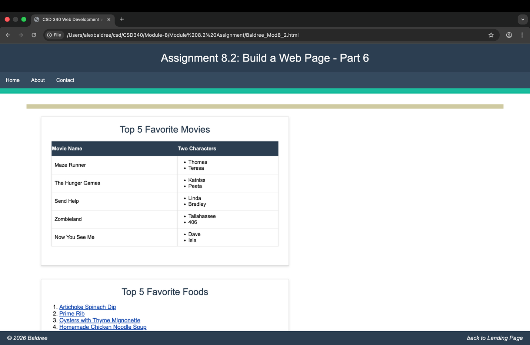

Output Bottom:
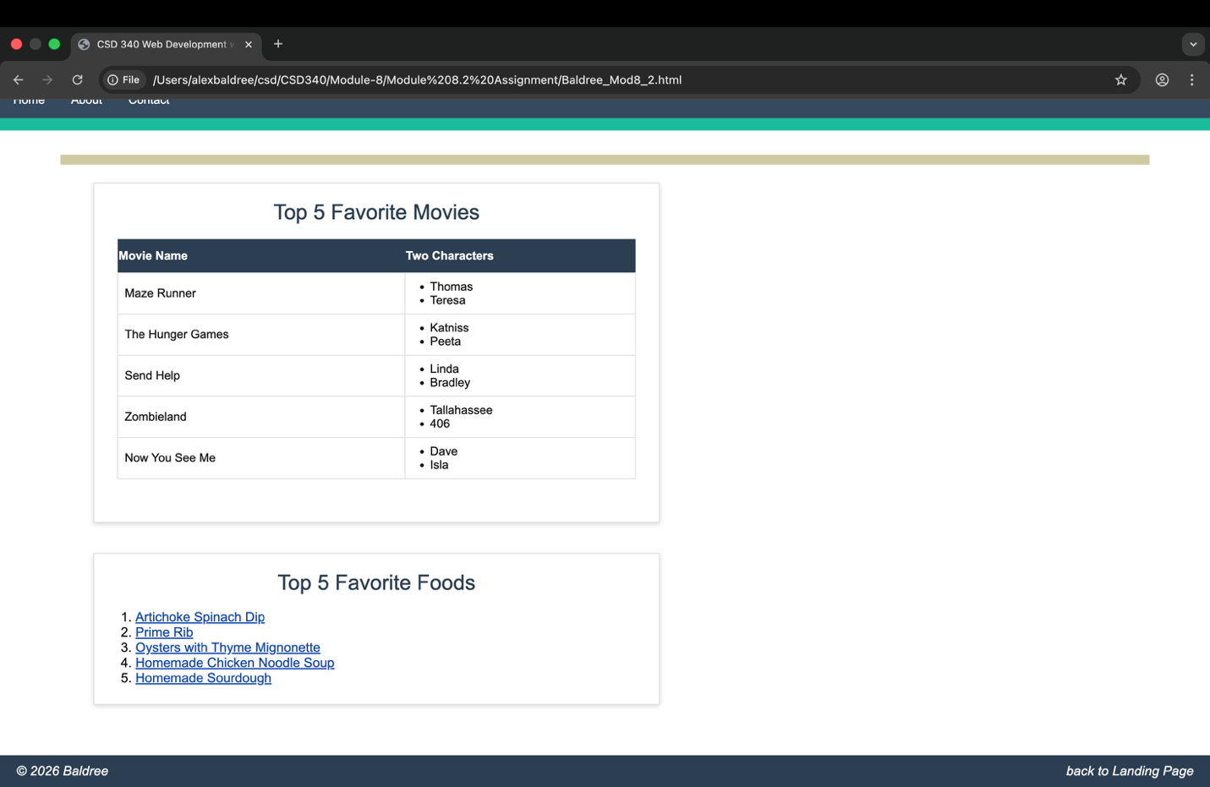

Code:
<!DOCTYPE html>
<html lang="en">
<head>
<meta charset="UTF-8">
<title>CSD 340 Web Development with HTML and CSS</title>
<link rel="stylesheet" href="Baldree_Mod8_2.css">
</head>
<body>

<header>
<h1>Assignment 8.2: Build a Web Page - Part 6</h1>
</header>

<div id="navbar">
<a href="#">Home</a>
<a href="#">About</a>
<a href="#">Contact</a>
</div>

<div id="container">

<!-- Movies Card -->
<div class="card">
<div class="card-title">Top 5 Favorite Movies</div>
<div class="card-content">
<table id="movies">
<thead>
<tr>
<th>Movie Name</th>
<th>Two Characters</th>
</tr>
</thead>
<tbody>
<tr>
<td>Maze Runner</td>
<td>
<ul>
<li>Thomas</li>
<li>Teresa</li>
</ul>
</td>
</tr>
<tr>
<td>The Hunger Games</td>
<td>
<ul>
<li>Katniss</li>
<li>Peeta</li>
</ul>
</td>
</tr>
<tr>
<td>Send Help</td>
<td>
<ul>
<li>Linda</li>
<li>Bradley</li>
</ul>
</td>
</tr>
<tr>
<td>Zombieland</td>
<td>
<ul>
<li>Tallahassee</li>
<li>406</li>
</ul>
</td>
</tr>
<tr>
<td>Now You See Me</td>
<td>
<ul>
<li>Dave</li>
<li>Isla</li>
</ul>
</td>
</tr>
</tbody>
</table>
</div>
</div>

<br>
<br>

<!-- Favorite Foods Card -->
<div class="card">
<div class="card-title">Top 5 Favorite Foods</div>
<div class="card-content">
<ol>
<li><a href="https://www.allrecipes.com/recipe/26819/hot-artichoke-and-spinach-dip-ii/" target="_blank">Artichoke Spinach Dip</a></li>
<li><a href="https://www.allrecipes.com/recipe/221958/chef-johns-perfect-prime-rib/" target="_blank">Prime Rib</a></li>
<li><a href="https://www.garlicandzest.com/oysters-with-thyme-mignonette/" target="_blank">Oysters with Thyme Mignonette</a></li>
<li><a href="https://www.delish.com/cooking/recipe-ideas/a51338/homemade-chicken-noodle-soup-recipe/" target="_blank">Homemade Chicken Noodle Soup</a></li>
<li><a href="https://www.delish.com/cooking/recipe-ideas/a25810151/how-to-make-sourdough-bread-recipe/" target="_blank">Homemade Sourdough</a></li>
</ol>
</div>
</div>

</div>

<footer>
<span>&copy; 2026 Baldree</span>
<span><a href="../../index.html">back to Landing Page</a></span>
</footer>

</body>
</html>

